**LAB 07 (Filling + UI) Sec B and F**

**Question # 1**

**TASK 1**

Create a class Medicine having following data members.

* Int id,
* String medName,
* Float medPrice,
* Int medQuantity

You attached file as Data base. You need write a class name as MY_DB. This class have following data members.

* List<Medicine> list_of_med
* int count_of_med

**Functions**

1. boolean read_file(String fileName)

* This function read file and keep all data in list_of_med. Return false if file reading fails

1. Boolean Add_medicine (Medicine m)

* Add medicine at the end of file in following format
* [id]space[Medicine Name]space[Medicine Price]space[Medicine Quantity]
* (return true if successfully added)

1. Boolean Delete_medicine (String name)

* Delete a medicine from list. But do not update file.
* (return true if successfully deleted)

1. Boolean decreace_medicine_quan (String name)
   * Decrease medicine price in list not in file.
   * (return true if successfully decreased)
2. Boolean increase_medicine_quan (String name)
   * Increase medicine price in list not in file.
   * (return true if successfully increased)
3. List<Medicine> getAllMedicines() (return a list having all medicines)
   * Return list of medicines
4. Boolean Comit_Data()

Write complete medicine list on file.

**Task 2**

Now create following UIs for above tasks.

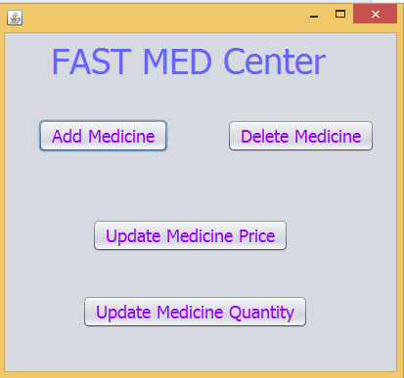 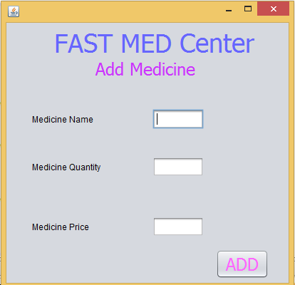

1. Do not accept empty fields.
2. Quantity and price should integer.
3. If a medicine is already exist then just generate an error.
4. You can generate error using following line.

JOptionPane.showMessageDialog(null, "Medicine already exist");

import javax.swing.JOptionPane;

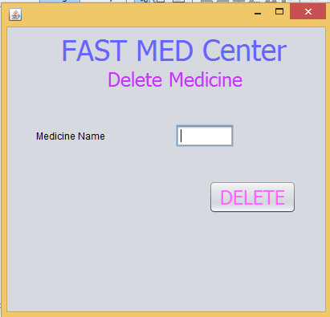

If medicine does not exist generate error.

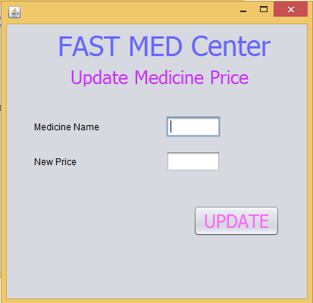 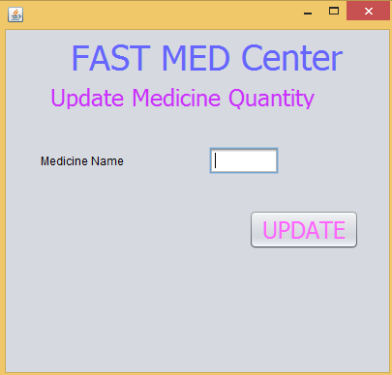

Apply all checks.

Decrease quantity by 1